**COMP 3015 Data Communications and Networking**

**Part 1. Project design report**

**Wong Tsz Shing 15225623**

This is a file sharing application which includes a server program and a client program. Users can access file from another computer. A user can have server program and client program at the same time. For example, user A can share some of his/her computer files with her friends by using server program, by putting certain files in a specific directory so that user B can download the file(s) or even the whole directory to his/her local computer when user B is using client program to remotely connect to user A’s server program. On the other hand, if user B also want to share his/her files to user A, user B can do the same way as above by using server program. For security reason, server program’s owner can set a password to control the access to these files. In the meanwhile, client program users need to provide the correct password to remotely connect to server program and access these shared files remotely. Other people are not allowed to do so. Moreover, this application support of multiple-user downloading and multithread downloading.

This file sharing application will use File transfer protocol (FTP). For multiple-user downloading and multithread downloading implementation, multithread programming is needed. It achieves concurrent usage by multiple client users and download several files concurrently.

For server side, First, the server program requires user to set a password to control access to the shared files. Once user set a password, it would not ask anymore. Second, the user need to set a specific path for sharing the files and put them into the path folder. After this, server program can wait and receive client request and respond corresponding function to client program.

For client side, First, the client program requires user to type in the IP address and the port number of the server program. Second, user need to input the correct password in order to remotely connect to the specific server program. If user types the wrong password, the client program requires the user types again until the password is correct. After authentication, user can perform the following a set of “User Commands”.

**Server side function:**

1. set(): this function let server user to set password and specific shard path.
2. showClients(): this function print the IP address of connected client program.
3. checkPassword(): this function check the received password from client program.

**Client side function:**

1. set(): this function let client user to set the IP address and port of the server program.

**Server side have no user commands.**

**Client side’s User commands:**

1. ls

This command allows the users to browse the shared files with the corresponding file name and file size.

1. cd + ‘directory’

This command allows the users to change to current directory to the ‘directory’.

1. pwd

This command prints working directory to the users.

1. get + ‘filename(s)’

This command allows the users to download or multithread download the selected files by input “get ‘filename(s)’” such as:

Example 1: “get 1.txt”. The example only download 1.txt.

Example 2:“get 1.txt 2.txt 3.txt”. The example will download 1.txt,2.txt and 3.txt.

1. getall

This command allows the users to download the whole directory by multithread downloading.

1. exit

This command allows the users to quit the program and then close or disconnect the connection from the network.

**Internal commands:**

1. 001 (map to ls)
2. 002 (map to cd + ‘directory’)
3. 003 (map to pwd)
4. 004 (map to get + ‘filename(s)’)
5. 005 (map to getall)
6. 006 (map to exit)

**Flow chart of the server program:**

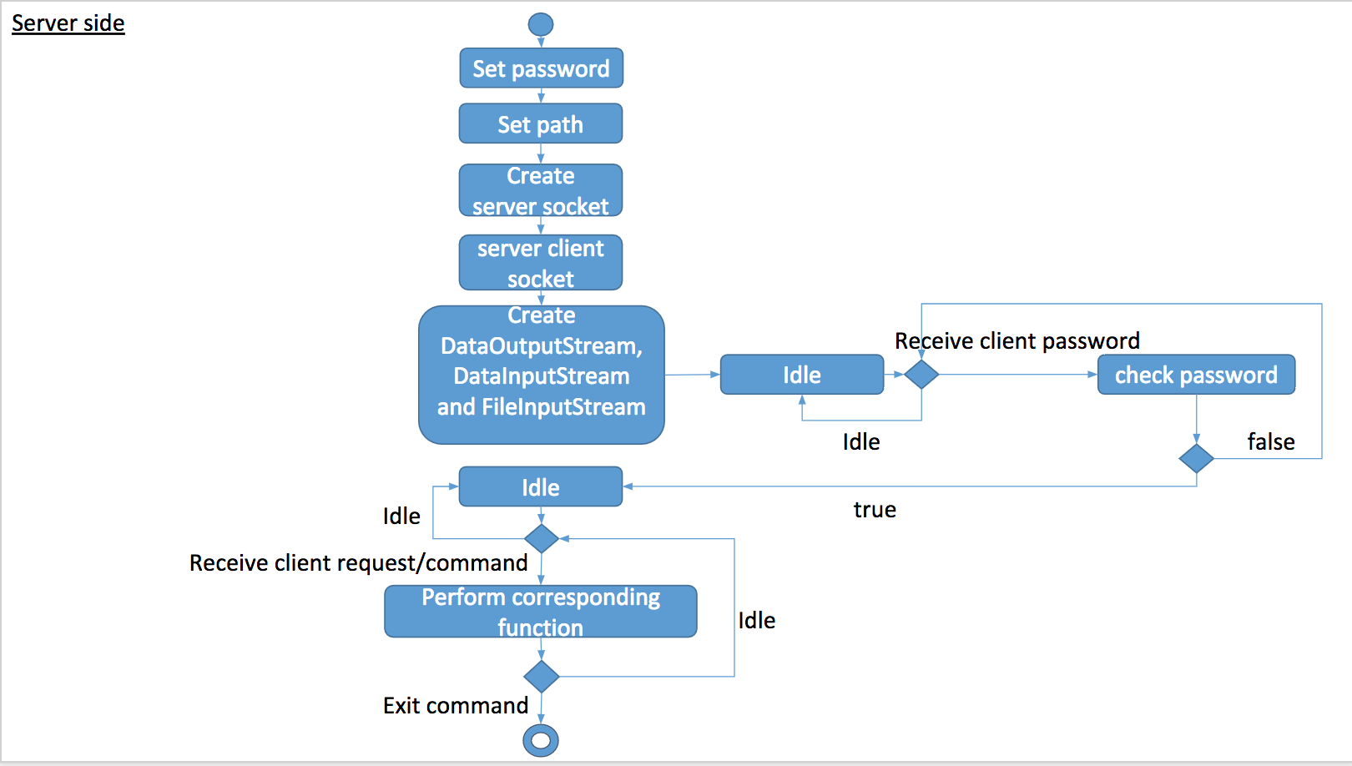

**Flow chart of the client program:**

